**PRESS RELEASE**

TROLLBEADS BRACELET: CELESTIAL WISHES BRACELET

*Embargoed until October 11, 2024*

**Celestial Wishes Bracelet – a limited edition from Trollbeads**

**As the holiday season approaches, Trollbeads introduces the Celestial Wishes Bracelet – a limited edition bracelet that captures the magic of the stars and the power of dreams. Featuring a stunning hand-faceted Golden Rutilated Quartz and exquisite sterling silver beads, this bracelet is a perfect reflection of the beauty and craftsmanship Trollbeads is known for.**

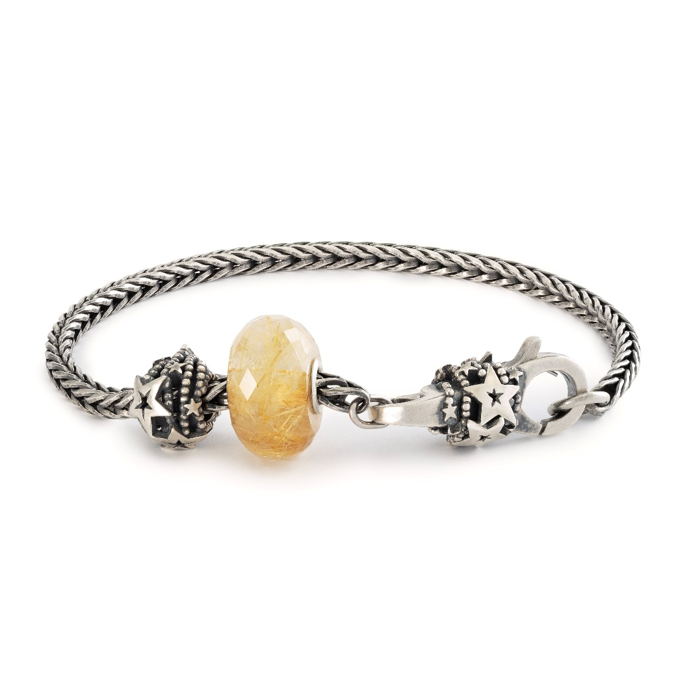

At the heart of the bracelet lies the radiant Golden Rutilated Quartz, its hand-faceted surface sparkling like stardust under the winter sky. Complemented by intricately designed sterling silver beads and a clasp inspired by shooting stars, this bracelet symbolises the magic of the night sky and reminds the wearer that the universe holds the power to make wishes come true.

**The perfect gift for the festive season**

The Celestial Wishes Bracelet is more than just a beautiful piece of jewellery – it’s a meaningful gift for those seeking to bring a sense of wonder and possibility to the holiday season. Whether worn as a symbol of personal dreams or given to a loved one, this bracelet is a thoughtful reminder that wishes, like shooting stars, are within reach.

For those who like to express their individual style, Trollbeads offers the option to pair this bracelet with their new leather cord, giving you a fresh and unique look. The Celestial Wishes Bracelet fits perfectly into Trollbeads' collection of innovative and carefully crafted jewellery, cherished by enthusiasts worldwide.

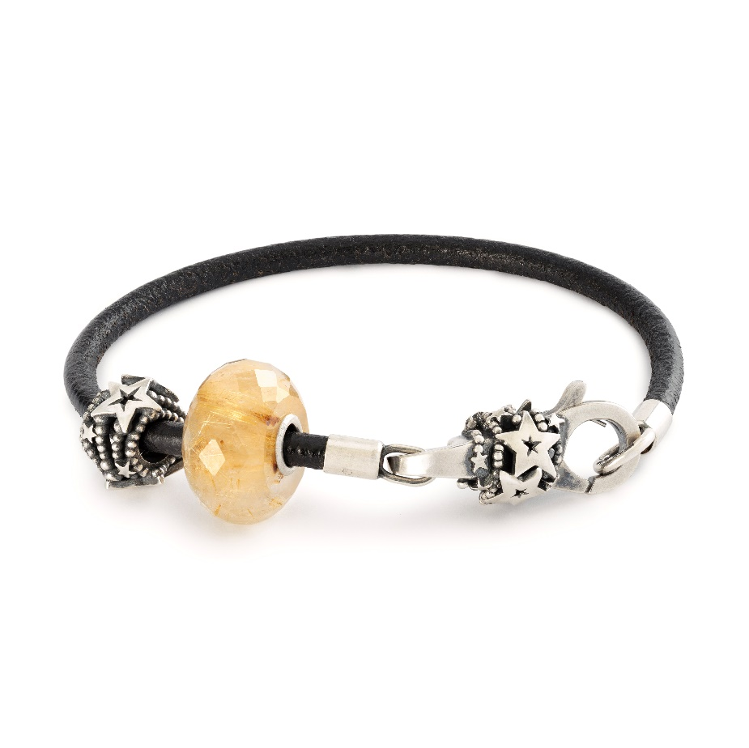

**Exquisite craftsmanship**

Trollbeads is renowned for its dedication to craftsmanship, and the Celestial Wishes Bracelet showcases this through its detailed sterling silver work. Each silver bead and clasp is crafted with precision, capturing the delicate beauty of shooting stars, while the Golden Rutilated Quartz is meticulously hand-faceted to ensure its radiant sparkle.

Despite its intricate design and high-quality materials, the Celestial Wishes Bracelet is available at a very attractive price, making it the perfect luxury gift this Christmas. With its unique blend of silver craftsmanship and celestial symbolism, this bracelet offers exceptional value for those looking to give a meaningful and lasting present.

The Celestial Wishes Bracelet is available in stores and online from 22nd November.

**Prices:**

Celestial Wishes Bracelet EUR 199, -

*For more information, visit* [*www.trollbeads.com*](http://www.trollbeads.com)

**[Contact Information – Insert distributor information]**

***FACTS:***

*In 1976, Trollbeads emerged within the cozy confines of a small jeweller’s boutique in Copenhagen, Denmark, heralding the inception of the beads-on-bracelet phenomenon. Crafted with meticulous care, Trollbeads offers an exquisite array of interchangeable pieces, with its centrepiece being the beads themselves. Each element in the Trollbeads repertoire harbours its own captivating narrative, drawing inspiration from a rich tapestry of mythology, astrology, fairy tales, wildlife, spirituality, cultural heritage, and the cherished nuances of everyday life.*

*From bracelets to necklaces, earrings, rings, and accessories, Trollbeads presents a diverse spectrum of products, bestowing upon customers a truly unique experience. Here, they transcend the role of mere consumers to become designers, crafting personalized tales with each carefully selected piece. This original concept has captured the hearts of women worldwide, seamlessly blending superior craftsmanship with individual preferences.*

*Crafted from the finest materials such as 18-karat gold, Sterling silver, Italian glass, freshwater pearls, amber, and precious stones, Trollbeads epitomizes a fusion of traditional artistry and contemporary techniques. Notably, since 2001, the brand has excelled in crafting artisan glass beads, revered for their uniqueness and allure. Each artisan glass bead is individually handmade from red-hot glass in the open flame and no two Trollbeads are ever completely alike.*

*As a hallmark of Danish design legacy, Trollbeads embodies the principles of simplicity, functionality, and uncompromising quality. At its core, design reigns supreme, with a dedicated team of artisans and designers meticulously curating each collection. Over 60 designers have lent their creativity to Trollbeads, earning international acclaim and recognition, showcased at prestigious events like the Sculpture Objects & Functional Art exhibitions in Chicago and New York.*